KKS6 -

Functionality
You use this transaction to calculate the variances for one or all product cost collectors for a particular material in the plant. As you want to calculate variances only for one particular product cost collector, you have to specify a production version.
The system compares the control costs with the target costs and assigns the variances to variance categories.
Target cost version 0 is used to explain the difference between the debit and credit of the product cost collector or manufacturing order. The target costs calculated on the basis of the current standard cost estimate are compared with the actual costs from which the work in process has been deducted. The difference is assigned to different variance categories depending on the cause. Only the variances calculated with target cost version 0 can be transferred to Profitability Analysis (CO-PA).
With target cost version 1, production variances for the product cost collector are calculated using the target costs determined on the basis of the preliminary cost estimate for the product cost collector. If you are using a product cost collector, the target costs cannot be determined on the basis of the preliminary cost estimate for the manufacturing order. Target cost version 1 is used for informational purposes. It cannot be settled.

Scenario
At month end, you want to calculate the variance of individual product cost collector created for a particular material and production version.

Requirements
Product cost collectors were created. WIP was calculated.

Menu Path | Accounting → Controlling → Product Cost Controlling → Cost Object Controlling → Product Cost by Period → Single Functions: Product Cost Collector → Variances → KKS6 - Individual Processing
Transaction Code | KKS6

1. Double click on KKS6 - Individual Processing

Variance Calculation: Initial Screen

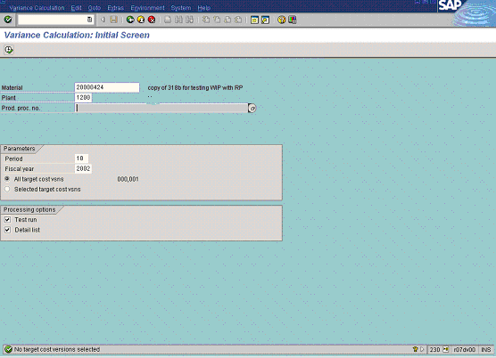

2. Update the following fields:

Field Name | Field Description | Values
Material | Code identifying a product or component | Example: 20000424
Plant | Code identifying the operational unit of the company where the material is manufactured and stored | Example: 1200

3. Press [F4] or click the Search button in the Production process number (production version) field.

Choose production processes for material/plant

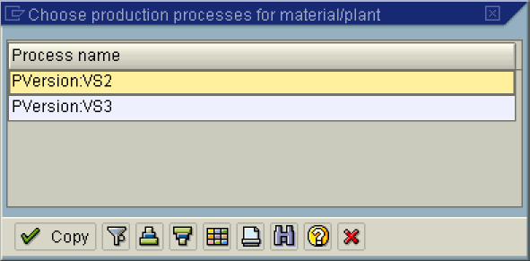

4. Double click on the PVersion:VS2 (production version) in list box.

5. Update the following fields:

Field Name | Field Description | Values
Period | Number identifying a fiscal month. | Example: 10
Fiscal year | Number identifying a fiscal year. | Example: 2002

6. Click the Test run checkbox to deselect.
7. Click the Execute button.

Variance Calculation: List

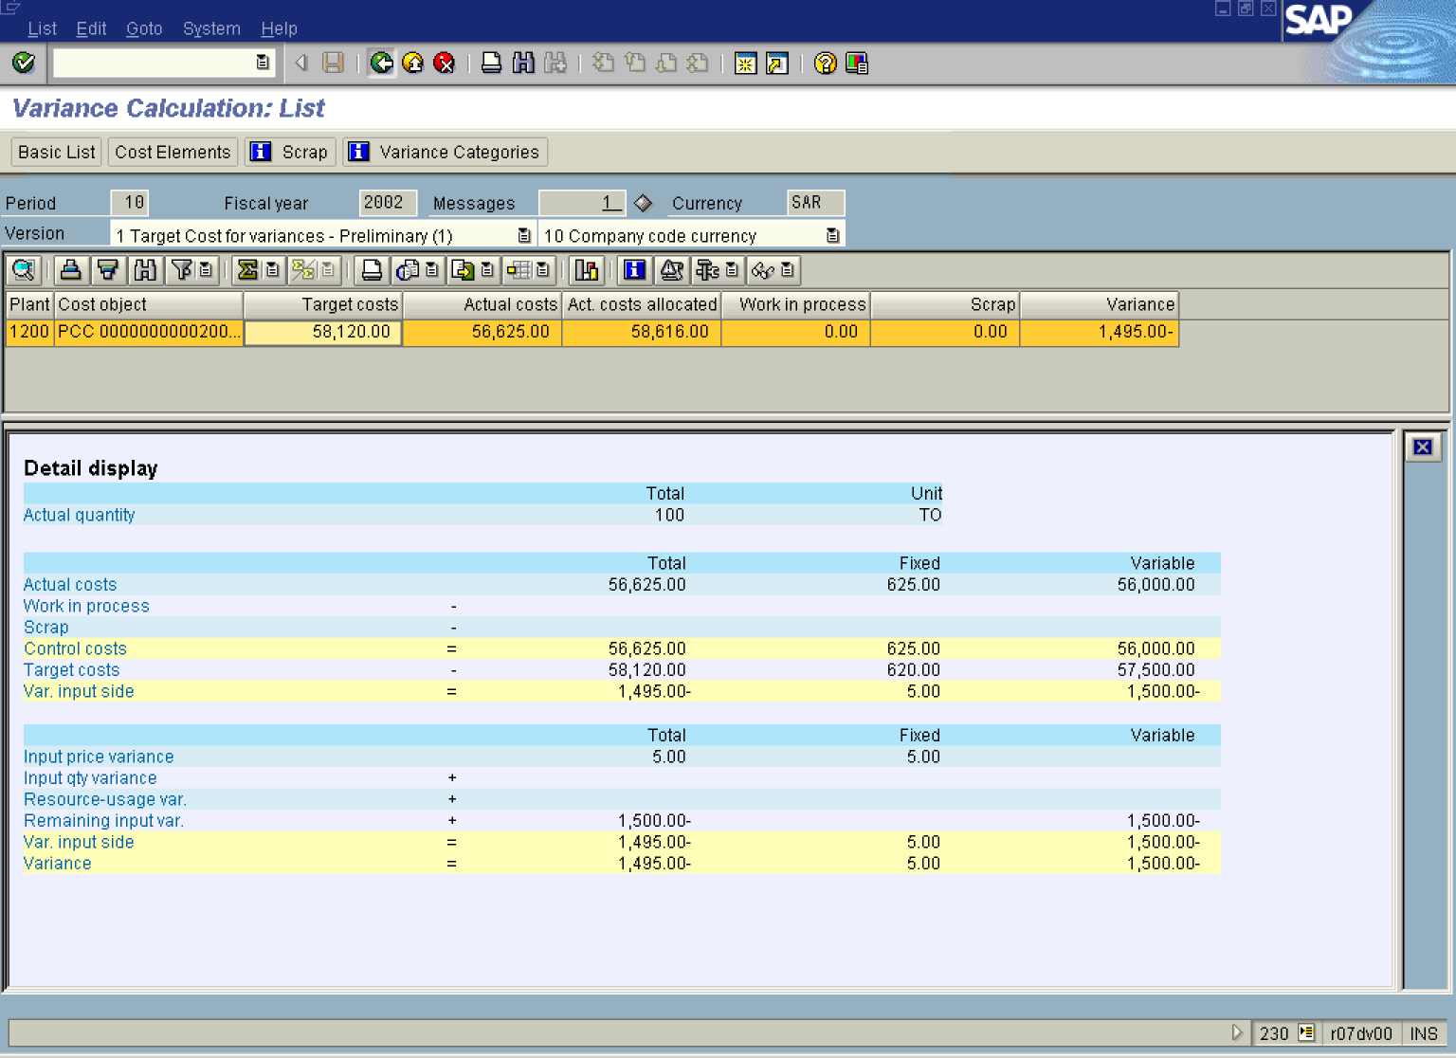

8. Select the Target Cost for variances - Preliminary (1) in dropdown.

Tip: Click the Variance Categories button to display detailed explanation of variances on the product cost collector.

9. Click the Back button.

